Federal State Autonomous Educational Institution of Higher Education

«OMSK STATE TECHNICAL UNIVERSITY»

Department of Computer Science and Computer Engineering.

**Report work**

on the subject «Foreign language» on the topic:

**«English-speaking Countries. Canada»**

Completed by: student of group IVT-244 Schmidt Anton Vladislavovich

Checked by: lecturer at the Department of Foreign Languages Prytkova Oksana Albertovna

Omsk 2024

Hello everyone. Today, I will tell you about Canada, one of the largest and most fascinating English-speaking countries in the world. We will explore its geography, climate, cities, industries, and culture.

**Location and Territory**

Canada is in the northern part of North America and is the second-largest country in the world, covering about 9.98 million square kilometers. It stretches from the Atlantic Ocean in the east to the Pacific Ocean in the west and northward to the Arctic Ocean. Canada shares the longest land border in the world with the United States, spanning 8,891 kilometers.

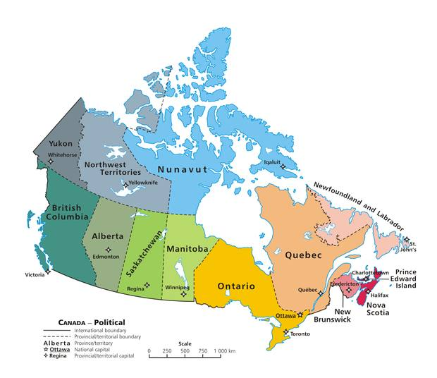

**Climate**

Canada has a highly diverse climate due to its large size. The northern regions experience Arctic and sub-Arctic climates with extremely cold winters and short summers. In contrast, the southern regions, particularly areas near the US border, have a temperate climate with warm summers and cold winters. Coastal areas, such as British Columbia, are known for their milder climates and significant rainfall, while the Prairies are characterized by dry summers and cold winters.

**Landscape**

The landscape of Canada is among the most varied in the world. The Rocky Mountains, which stretch through British Columbia and Alberta, are a major tourist attraction and home to famous national parks like Banff and Jasper. The Great Lakes, five massive freshwater lakes, are shared with the United States and form a critical part of Canada's geography. The Canadian Shield, a vast region of ancient rock covering about half of the country, is rich in valuable minerals such as gold and nickel. Niagara Falls, located on the border between Ontario and New York State, is one of the world's most famous natural wonders. In the far north, the tundra and Arctic regions are dominated by permafrost and unique ecosystems.

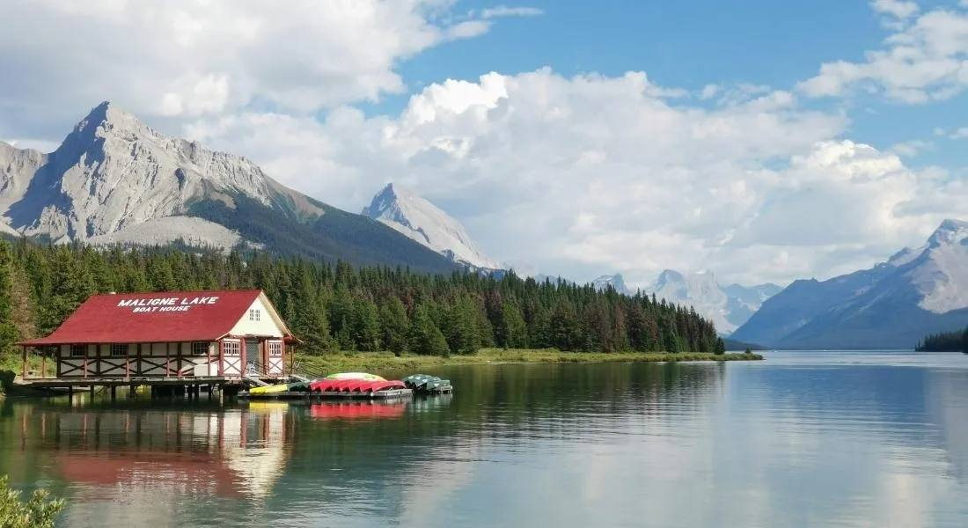

**Capital and Main Cities**

Canada’s capital is Ottawa, located in Ontario. It is known for its historic Parliament Hill and cultural institutions like the National Gallery. Toronto, the largest city, is a global financial and cultural hub, famous for the CN Tower. Montreal, located in Quebec, is renowned for its French-speaking culture and vibrant arts scene. Vancouver, a coastal city in British Columbia, is notable for its stunning harbor and proximity to the mountains. Calgary, in Alberta, is famous for its oil industry and the annual Calgary Stampede.

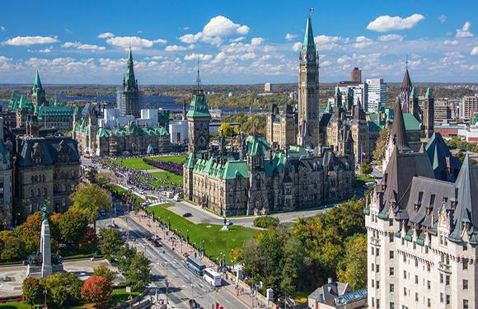

**Industry**

Canada’s economy is highly advanced and relies on several key sectors. Natural resources play a major role, with Alberta being a leading producer of oil and gas, while mining contributes significantly through the extraction of gold, nickel, and uranium. British Columbia is a leader in forestry and timber production. The country is also a hub for technological innovation, with companies in Toronto and Vancouver excelling in AI, gaming, and software development. Manufacturing industries produce vehicles, machinery, and aerospace technology, while tourism attracts millions of visitors annually to destinations like Banff, Quebec City, and Niagara Falls.



**Agriculture**

Agriculture in Canada is modern and productive. The Prairie Provinces, including Alberta, Saskatchewan, and Manitoba, are the primary regions for growing wheat, canola, and barley. Ontario and British Columbia are known for their vineyards and fruit orchards, while dairy farming is a significant industry in Quebec and Ontario. Canada is one of the world’s largest exporters of agricultural products, particularly grains.

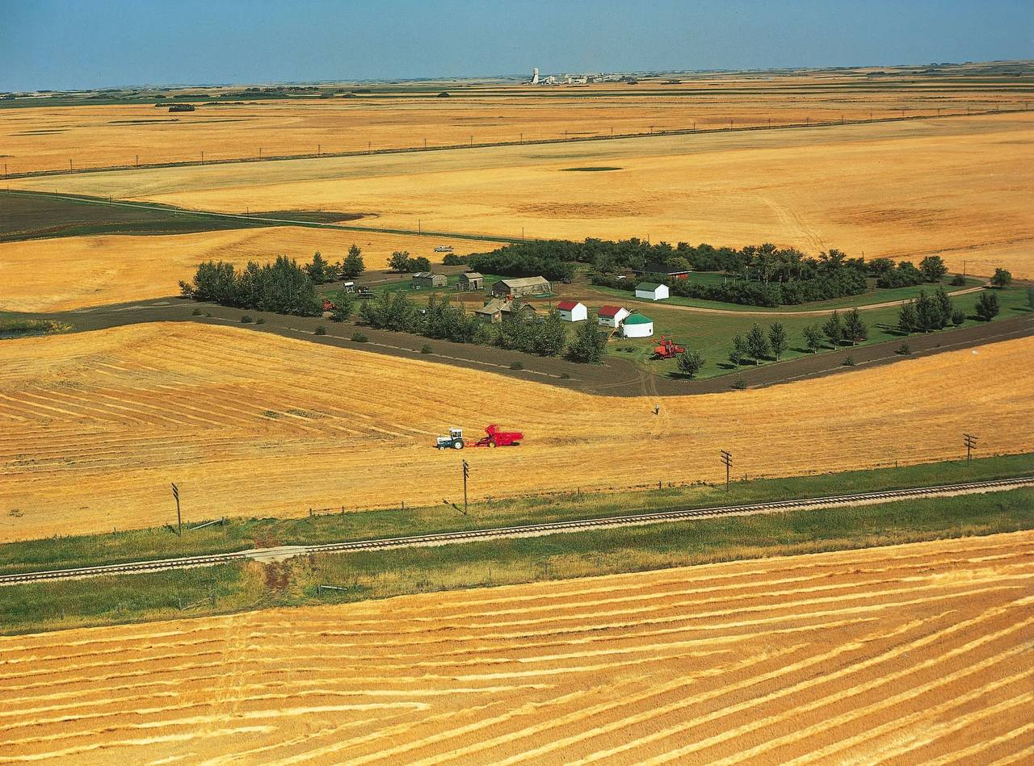

**Political System**

Canada is a constitutional monarchy and a parliamentary democracy. The symbolic head of state is the King or Queen of the United Kingdom, represented in Canada by the Governor General. The Prime Minister is the head of government, leading the executive branch. Canada’s federal structure divides power between the national government and ten provinces, each of which has its own premier and legislature.

**Population**

Canada has a population of about 40 million people. The majority live in urban areas, especially near the US border. It is a multicultural society, welcoming immigrants from all over the world. Canada has two official languages: English, spoken by 75% of the population, and French, spoken by 23%, primarily in the province of Quebec.

**Education**

Canada is known for offering one of the best education systems in the world. Primary and secondary education are publicly funded and free up to Grade 12. The country is home to prestigious universities such as the University of Toronto, McGill University, and the University of British Columbia. Canadian education emphasizes research and innovation, particularly in technology, engineering, and healthcare.

